Compiled ^

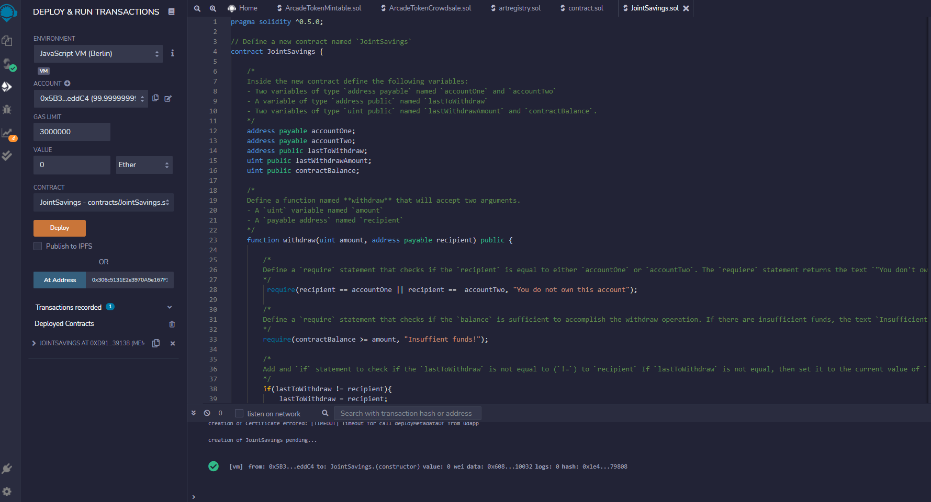

Deployed ^

Transaction 1: Send 1 ether as wei. ^

Transaction 2: Send 10 ether as wei ^

* Transaction 3: Send 5 ether.^